Workshop Report On

Aviation and Climate Change - Challenges on a Global and Equitable Solution

Organized by; LAYA- INECC and Bread for the World, Germany
Dates; 9th and 10th May 2013, Hotel Mapple Emerald, New Delhi
The workshop Aviation and Climate Change: Challenges on a Global and Equitable Solution was organized by LAYA-INECC and Bread for the World. It was organized to provide an overview of existing developments and framework for curbing emissions from international aviation. At the same time it was also an attempt to bring together civil society organizations both nationally and internationally to reflect upon, discuss and exchange views on matters related to climate change and aviation with focus on equity and sustainable development. The workshop attempted to understand India’s official position at ICAO (International Civil Aviation Organization). It was also the first attempt to create space for grassroots civil society towards initiating a learning process wherein NGOs could understand and work with global perspectives that linked concerns of aviation emissions with Climate Change.
The duration of the workshop was one and a half day. The first session focused on different dimensions of equity and regulation and the implications and effects of aviation emissions. The afternoon session consisted of a panel discussion on the challenges for a global framework and India’s position at ICAO. The second day was divided into two sessions. The second day began with a recap of the previous day followed by presentations of representatives from airlines-Jet Air, Air India and Boeing. The second session consisted of discussing the learning and suggestions by breaking into three groups followed by a presentation of the main points by a member of each of the groups. (Attached programme schedule for reference)

Day I

9th May 2013

Welcome Note – Nafisa Goga D’Souza,

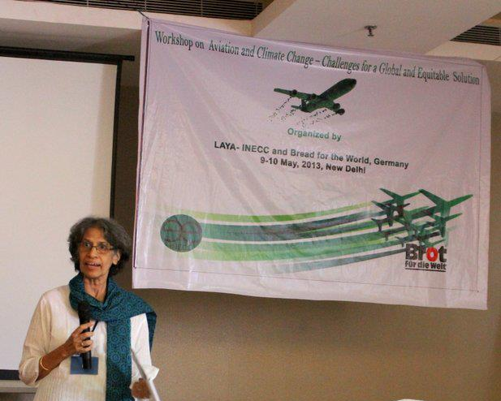
Executive Director LAYA-Convener INECC.
The workshop began with a welcome note from Nafisa Goga D’Souza. She thanked the participants who had come to contribute to the workshop from various parts of India and from abroad. She acknowledged that although everyone had contributed to some level of emission for the purpose of the workshop, she hoped that it would serve as a motivation to discuss and reflect on the issue that would foster greater understanding and creative solutions. She mentioned that for INECC and others present in the workshop involved in grass-roots work on issues related to the climate change the workshop was an opportunity to understand the links between climate change and aviation to larger questions of equity and sustainable development which were INECC’s priority areas.
She apprised that aviation was a fast growing sector wherein emissions from the aviation sector had more than doubled in the last 20 years. This made the aviation sector critical from the emissions point of view. In India the air traffic has increased greatly. Even in smaller cities like Vishakhapatnam the situation has become such that it is difficult to source air tickets easily. So there has been an increase in the expansion of the aviation sector as well as in that of the cargo. Given the global implications of the aviation sector she expressed that there is a need to connect with larger global perspectives particularly related to advocacy and action for a global equitable regime.
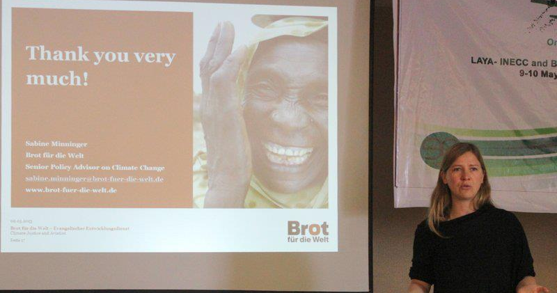
She emphasized however that the grassroots communities must be the stake-holders and marginalized communities need to be compensated for climate preservation. She hoped that this learning workshop would lead to further engagements and positive efforts.

The dimension of equity in aviation- Sabine Minninger, Bread for the World (BfW)

Moderated by: Walter Mendoza
In this session Sabine gave an overview of the debates that were taking place on the issue of climate change and aviation emission. She said that discussions so far had very often been confined to the NGOs of the global north and not been inclusive of voices of the global south. She felt that it was necessary to make these discussions on frameworks and regulations more inclusive of the Civil Society Organizations (CSOs) of the developing world. At the same time, the concerns and priorities of the NGOs of the global south working with the grassroots on issues related to climate change could benefit from the discussions and linkages with efforts and perspectives aligned towards the reduction of aviation emissions. The present workshop would help outline each other’s positions and to envisage possibilities for learning and working together.
In her presentation she gave examples of islands in the South Pacific which had been submerged due to rise in sea-level as a result of climate change. All attempts to adapt the islands so far had failed and there were rehabilitation programs being undertaken to save the inhabitants who did not have access even to drinking water which had to be imported. She quoted from the Human Development Report 2013 which stated that "Environmental inaction, especially regarding climate change, has the potential to halt or even reverse human development progress. The number of people in extreme poverty could increase by up to 3 billion by 2050 unless environmental disasters are averted by coordinated global action. “She noted that on the dimension of climate justice and aviation it was important to note that emissions from aviation were responsible for 4.9-14% of global warming (Lee et al, 2009) and is projected by 2050 to be responsible for 25% of global warming. The aviation industry had shown a growth rate of 3-4% growth in 2013. However, only 2% of the world population actively takes part in aviation wherein almost 80% of all flights are for holiday reasons only (Last call to Durban. "Beyond Numbers: A call for social, economic and climate justice in tourism" (2011, Tourism Watch et al)
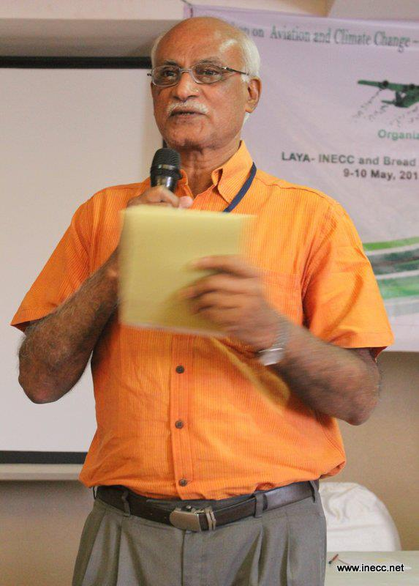
In the recent times all over the globe there has also been massive expansion of airports and low-cost carriers. The UNFCCC reviews global emissions but does not address emissions from global tourism. The carbon emissions are legally regulated in the Kyoto Protocol but the bunker emissions escaped binding regulations even though bunker fuels account for approximately 10% of global emissions (Bunker fuels and the Kyoto Protocol (Transport & Environment 2009). Under the Kyoto Protocol the responsibility for the bunker emissions was handed to ICAO and IMO (Article 2.2).
In terms of the framework and guidelines the UNFCCC differentiates between Industrialised and Developing Countries-Common but Differentiated Responsibility-Principle (CBDR) but the ICAO follows the equal treatment - Non-Discrimination-Principle. There was a resistance from the developing countries as they do not want to be imposed to take the same burdens as developed countries and therefore they call for upholding CBDR in relation to Equity. But given that aviation emissions have an international nature, addressing equity becomes a real challenge.
There could be a positive outcome of the Copenhagen Green Climate Fund for climate financing in developing countries. Aviation and shipping have been identified as innovative climate finance sources for poor countries according to the polluter-pays principle. All funds generated from a global aviation scheme (up to 10 billion USD) should be channeled to poor countries. Other solutions like weak offsetting mechanisms would not work and agro-fuels are not yet an option both on grounds of commercial viability or long term sustainability.
If the aviation sector is left unregulated the target to keep global warming below 2 degrees cannot be achieved. She emphasized that addressing flight emissions might increase air ticket costs around 2-3% (High-Level Advisory Group on Climate Change Financing by Ban Ki-Moon, AGF report, 2010) and no matter what the nationality it is only the rich who fly. However, Developing countries also express concern that they do not want finance from sources which are already included in their economies such as the aviation sector.
So the dimensions that emerge she noted were:
- Systemic reduction of emissions within the sector
- Creation of a global fund in the lines of the Copenhagen Green Climate Fund for Financing in Development-which would have a large potential to generate finance and protect the poor and the fragile communities.
She emphasized that it needed to be a global scheme and global solutions. Germany she said, the aviation sector is highly advantaged compared to other transport modalities, the local domestic travel is highly subsidized and the market is an artificially created one. They have privatized the trains and made them very expensive. Flying is in most cases not always necessary, it is a lifestyle question. So the key issue is about equity wherein the rich people no matter their nationality must pay for the damage they cause to the environment.
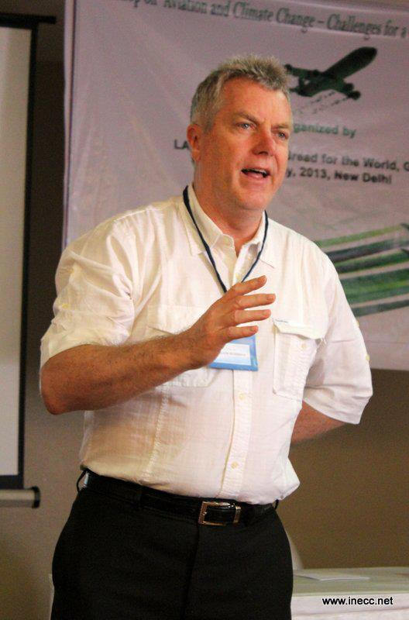
Aviation and Climate Change: Bill Hemmings, Transport and Environment, Brussels
Bill Hemmings in his presentation drew from his position and experience of being an advisor in the Transport and Environment (T&E), a Brussels based European Federation working on formulating fuel efficiency standards for Europe which also serves as an NGO Observer at ICAO since 1999 among various other positions in organisations that were involved in issues related to the environment and climate change. His emphasis was on the upcoming ICAO discussions and the importance of the EU-ETS. He noted first of all it was good to be able to fly and visit different places and countries. However, what had to be taken care of was to make aviation more efficient and responsible to the global environmental concerns. He presented the statistics which showed that 80% of aviation emission comes from tourism and even then most airlines are reluctant to have taxes on aviation fearing decline in passenger flows. ICAO had been mandated to look into aviation emissions by the UNFCCC for almost 20 years but it has not come up with anything substantial so far. In response, EU decided to address aviation emissions thorough the ETS (Emission trading scheme) and subsequently came up with a legislation applicable to all EU and Non EU airlines. However, this decision of theirs faced resistance from almost all concerned countries on account of being unilateral, undemocratic and inequitable. ‘The Coalition of the Unwilling ’have expressed their protest against the unilateral action of the EU as an unfair practice. Following this, the EU has stopped the clock for the international inclusion of emissions from aviation under the precondition that until January 2014 a global scheme will replace the regional solution of the EU.
Aviation not only results in carbon emissions but also NOX gases whose effects on human life forms have not been fully explored. The impact on global warming from aviation emissions has been about 5%. Europe even under the economic crisis the aviation emissions increased and the traffic grew by 11% in the last 5 years. He also pointed out that emissions grow less than the traffic.
Main points of his presentation:
Aviation is the fastest growing source of greenhouse gas emissions in the transport sector and the most climate-intensive form of transport. International aviation emits more CO2 than France or Australia. Aviation emissions have more than doubled in the last twenty years and the sector accounts for 4.9% up to 14% of total worldwide emissions contributing to climate change. The worrying aspect is, that by now only 2-3% of the world population is frequently flying mainly (80% of flights) for tourism reasons. And left unregulated, aviation emissions are on pace to quadruple by 2050 forming by then a very significant proportion of a global carbon budget consistent with keeping warming below 2°. Therefore global targets to reduce emissions within the aviation sector are urgently needed.
Tracing the history and looking at the ICAO work on political and technical issues he brought to notice that in 1998-2010 the work by ICAO dealt in open and closed trading systems; taxes, charges; offsets, voluntary initiatives. But by 2004 it clearly decried any global schemes but recommended national/regional emissions trading systems. The 2009 High Level Meeting on Climate Change lead to the declaration on design of MBMs; “Basket of Measures” and in 2010 Agreement was to pursue CO2 standard for new aircraft and new noise standard. In the 2010 discussion on climate change lead to no consensus. The 37th Assembly Resolution requested the ICAO Council to review the 1% global RTK de minimis threshold and develop a framework for market-based measures (MBMs) and to explore the feasibility of a global MBM scheme by undertaking further studies on the technical aspects, environmental benefits, economic impacts and the modalities of such a scheme and to report progress to 38th Assembly Group of Experts established January 2012. But the progress so far has been alarmingly little with no consensus visible in the near future.
Aviation has always received special treatment, for example it is not subject to any fuel tax or VAT. Taxes on aviation have been actively resisted and India and Brazil which do have domestic tariff are under pressure to reduce them.
The principle of Common but Differentiated Responsibilities (CBDR) could still be respected if revenues raised by global policies (levied mostly on well off consumers) were spent on climate protection in developing countries. Further a global policy should ensure that developing countries incur no incremental costs. In the aviation sector options to be explored include a rebate mechanism and limiting the policy to flights into and/or out of particular countries by applying the “de-minimis-threshold” to Least Developed Countries and Small Island Developing States. Well-designed policies to control aviation emissions could pay a double dividend – reducing emissions but also unlocking major flows of predictable climate finance. Civil Societies from India should get involved in the current negotiations in ICAO now to ensure a global deal is significantly reducing emissions in the sector, respecting equity and avoid false solutions such as large scale offsetting.
Questions/Comments
- Is there a breakup for emissions coming from cargo and aviation?
The emissions from aviation is 80% of the total and Cargo is around 8%.
- Where are these proposals for a global scheme coming from?
These are ideas being negotiated at the moment in the global north.
Aviation in Carbon Markets: Eva Filzmoser, Carbon Market Watch, Brussels
Eva Filzmoser’s presentation gave an overview of the role of carbon markets in aviation and the existing frameworks for MBMs. She also laid out the possibility of global MBMs and the risks involved in offsetting. She put forth that was necessary to discuss and intervene through MBMs given that that these seemed to be the only solutions under discussions on framework for global aviation emissions at the moment. She quoted from David Lee’s Emission Gap Report (2013) “Of the three types of measures studied, extension of current regional market-based measures [i.e. the EU ETS] offers the greatest mitigation potential.” She emphasized that we are only 5 months away from the next ICAO GA (September 2013) to agree on a roadmap for a global MBM and therefore the importance of this issue.
In 2013 the High Level Group Meeting focused on the “basket of measures“, e.g. state action plans, operational measures, CO2- standard, alternative fuels. The Group‘8 countries (Singapore, Belgium, Brazil, China, India, Mexico, UAE and USA) proposed framework for MBMs to support States that would like to implement their own measures, e.g., regional ETS and the HGCC invited to consider the draft framework for MBMs at their next meeting in June 2013. This framework, she informed does not set precedence for UNFCCC and does not prejudge implementation of a global MBM and if a global MBM scheme be put in place the framework will cease to apply. The objectives are to avoid double counting, minimize carbon leakage and market distortions, recognize past and future achievements, include de minimis provisions, apply revenues generated from MBMs to mitigating the environmental impact of aircraft CO2 emissions, facilitate appropriate access to all carbon markets and ensure fair treatment of the international aviation sector in relation to other sectors. The Kyoto Compliance Market takes note of a) Clean Development Mechanism (CDM) and b) Joint Implementation (JI). Outside UNFCCC there are
Voluntary offset programmes
- National offset programmes
- Bilateral offset mechanisms
- Regional offset programmes
Offsets could be beneficial as they are cost effective generally involving less administrative burden than setting up emissions trading schemes and can be a source for climate finance in developing countries. Currently the most preferred option is seen to be an offsetting system would require airlines to pay into a central fund that would purchase carbon offsets. The current (informal) option is based on 100% offsetting and if no additional measures and standards are put in place, this could be more damaging than no agreement. However, there are a number of risks involved. Serious concerns exist about environmental integrity of offsetting projects on many levels as they are not a long term solution because it does not reduce but compensates emission reductions and compensation of emissions reductions delays reductions in the aviation sector itself. Quality restrictions are needed to ensure that only CERs that come from projects with high environmental and social quality are eligible. The voluntary offset programmes currently operating would not deliver large enough volumes to satisfy the needs of ICAOs potential scheme. Offsets from such voluntary schemes are often of low quality due to limited or no regulatory oversight. Because of the limited regulatory oversight, offset credits from the voluntary market should not be eligible for compliance under an ICAO scheme. Offset credits from bilateral offsetting mechanisms without the oversight of UNFCCC should not be eligible under an ICAO scheme. Cap-and-trade systems only lead to emissions reductions if there is a scarcity of allowances.
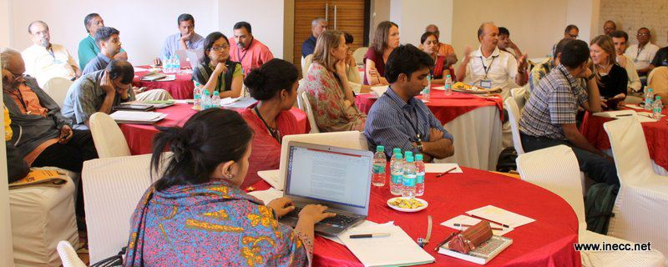
The UK proposal for a global MBM was a last minute proposal for completion by Council at the September Assembly related to allocating emissions limits/responsibilities, harmonised MRV system, and effective administrative system, quality criteria for offsets and timetable and legal mechanisms for the introduction of a global MBM. If left unmitigated international aviation and shipping emissions will take up ~30% of the 2° degree emissions budget by 2050. Most importantly it was essentially to change life-styles.
Questions/Comments/Discussions
- Who would pay the additional tariff and where does it go? What happened to the fund in the case of EUETS?
Response: It would be the airlines that would pay but the countries may not use it for climate activities or mitigation. Only Germany has earmarked for climate activities. Why should the government of India have no intent in that?
- Comment: How would countries spend the money? Say in the case of India there have been massive misuse of funds allocated for the forest cover. But the results have been far from satisfactory -where does the money go? Addressing this is an important aspect.
- Given that there are domestic market for emissions and the international market is being treated differently, what are the responsibilities being put on both? Are there any different measure for CDM or offsetting or are there any guidelines to establish this kind of mechanism?
Response: There is a lot of flexibility and the basket of measures can serve as a reference point. India is a new buyer and offsetting mechanisms can have positive effects on climate change. India has a tax on fare and they can incorporate that this can be used as a global scheme. So far the voluntary offset mechanism has not worked and the uptake has not been more than 2%.
The EUETS which as an attempt was seen as an infringement and it was not agreed to by other countries and was discarded as a defective scheme. But so far it was the only one which was trying to put into action certain guidelines and requirements.
- There are often good mechanisms that are not popularized or heard of much, are there ways of making these information further available to grassroots organizations?
Response: It is true that many of these information are very technical and we have to work to make them more accessible. There are a lot of small projects that are working at the ground with these issues and we have to form and strengthen NGO networks towards this end.
- Is there no possibility of furthering bio-fuels?
Response: Different studies so far have shown that bio-fuels are not a viable solution both economically or on the question of sustainability, they are at present prohibitively expensive and issues related to land rights, food security also get enmeshed in it. At present they are attempts being made to develop algae but it is yet to take off.
Myths and truths about tourism Sabine Minninger, Bread for the World
Tourism in Developing Countries is seen to be an important contributor to the MDGs and it is often said that “the travel sector should not be disadvantaged through the imposition of a disproportionate burden either on tourism as a whole or on vital components such as aviation” (UNWTO). But it is also an obvious fact that many countries which are thriving tourist destinations are also the worst off in terms of the level of poverty. It is only a small elite that benefits and large sections barely survive even as their livelihoods and habitation are under continuous threat. Many multinational corporates own the resorts and are buying off prime land in many developing countries and it is they who benefit and not the local people who may get jobs at the lower levels and hardly earn enough. So there is high revenue leakage rate from tourism in developing countries, the poor do not profit from unsustainable tourism as a lack of participation etc. For example the Tourism in the South Pacific might have a80% revenue leakage rate that accrues to foreign investors, international tour operators, imports. Poor people do not benefit from tourism, but small elites. It can be seen that tourism creates poverty related to: water access, land rights, indigenous people discriminated, human rights violation, commercial sexual exploitation of children and women in tourism. Figures from the UNWTO show that 5% of global emissions caused by tourism, experts estimate up to 12,5% wherein on a long-haul trips97% emissions are caused only by the flight. Forecasts show that carbon emissions from tourism will grow by 162% during 2005-2035 (UNWTO, 2008).
In terms of tackling the emissions the UNWTO emphasized that “much will eventually come from the private sector with its appetite for innovation” but so far in terms of mitigation there have been no changes in the travel behaviors. It thus, appears that measures on a voluntary basis might fail to reduce emissions. So far any binding emission reduction mechanism for aviation, for instance a global fuel tax or emission trading scheme or flight ticket levy that would result in increased costs for passenger transportation have been resisted on the basis of negative impact on the economies of developing countries. This view has been supported by ICAO, UNWTO, tourism depending countries, tourism industry interest groups, etc.
The need of the hour is to call for a transformation of tourism towards more sustainability, justice, fairness, participation in order to alleviate poverty instead of increasing poverty by unsustainable practices. Poor people need support in capacity-building and market linkages to benefit from tourism. It is important to see tourism has rather not be used as an excuse to block climate protection in aviation but to be turned into a development motor that is sensitive to people’s and the planets sustainability.
Questions/Comments/Discussion
- Why do local communities get the least benefit from tourism?
Response: Because they are excluded from the market and they cannot participate. Foreign investors do not allow them and they are excluded from decision making processes. We have to work towards empowering them. But the UNWTO has always barred the NGOs from taking part in the discussions. The few NGOs working in this area in India are doing great work.
- Tourism is made possible as flying is cheap in the northern countries, what is the level of advocacy there? What efforts are being undertaken to educate people about the harmful effects of tourism?
Response: It is a new position in the climate change debate and it is a big issue. So far there is not much that has been going on especially since tourism is considered important for the economies of the developing countries. All over Europe there are only two NGOs working on this issue and it is yet to expand. It is not considered a big deal.
- Between tourism and aviation-what percentage is contributed by each to emissions?
Response: In a long haul trip 97% is by aviation.
- Is eco-tourism making an impact?
Response: There are many good examples but so far mass tourism has out-spaced them. And many of these enterprises in turn are being run by multinationals and private investors which defeats the purpose. But there are loads of good approaches that need to be followed up. There were attempts to make the German tourists carry their garbage home but there is not much these measures will amount to and there are instances where the airlines have touted disposable meal trays as being their contribution to climate friendly activities.
- The issue of tourism is pertinent to the Himalayas. There needs to be a master-plan for tourism as there is a huge takeover of Himalayan tourism from the local control. There is an NGO working on eco-tourism-EQUATIONS.
- All said and done it is important to note that for some countries tourism is the only source of income and however it may be a rise in the GDP is important for the well-being of a country where poverty may be due to lack of industry.
Response: There is a need to interrogate these ideas. There is another truth where tourism perpetuates poverty and inequality. For example in Fiji they gave away their fishing rights to the Chinese and they have to diversify.
- The discussions at the ICAO seem not to be so much in our hands but we need to focus on issues related to equity. It is a rich man’s disease.
Afternoon Session III: Moderator: Moderator: John D’Souza, CED

Challenges on a global regulation for aviation Tirthankar Mandal, CANSA

Moderator: John D’Souza, CED, Mumbai
The presentation drew from a study that was looking at how to address the challenges related to climate change, equity and aviation. The global aviation was responsible for 2-5% of annual CO2 emissions according to the 2005 data. But there are also NOX gases apart from the CO2. The IPCC looked at impact from all the gases which have to be regulated and reduced.
The EUETS as an aviation scheme is unilateral and does not ascribe to CBDR. There are some principle problems involved in this. At CANSA the attempt has been to work out some of the alternative mechanisms to regulate the emission. Since the emissions are production based the issue of extra territoriality comes in which also raises questions related to sovereignty. To tackle the aviation emission-target for keeping the global temperature below 2 degrees there need to be a principle based approach. Firstly, it has to be underlined that it is a mitigation responsibility should not be used as a precedent and thereby has to have definite safeguards against its use in other sectors. Secondly, it should not be unilateral. The outcomes of the ICAO and UNFCCC process should not be prejudged. The best way forward is to arrive at a consensus at in ICAO to be then taken forward by the UNFCCC.
He mentioned that what they were proposing was that in addition to the MBMs there needs to be nonmarket based measures-common standards, efficiency standards, mechanisms to allow for technology cooperation within the aviation sector, differentiation in terms of allocation of targets and allowances. These can be modeled in the Montreal-differential role for the developing and developed counters and greater use of offsets by developing countries, allocation of allowances and the revenue raised should be reverted to the developing countries to be used in controlling the emission.

India`s position in ICAO, T.S. Tirumurti INDIA Joint Secretary (UN), Ministry of External Affairs, Negotiator in ICAO

Moderator: John D’Souza
Mr Tirumurti stated that India’s position has remained unchanged on addressing aviation and MBM (Market Based Mechanism) in particular. He said that the discussion was extremely important and it was necessary to explain the logic of India’s position. Firstly, the EUETS was a unilateral decision. This lead to justifiable concerns regarding the change in paradigm. After the initial dialogue, it was concluded that the EU stop the clock and further discussion on this account awaits at ICAO in Montreal.
On India’s position in the ICAO he stated that the important point was to tackle climate change. He noted that equity could not be addressed through MBMs and that the feasibility of MBMs have yet to be established. Most importantly MBMs have to be ‘voluntary’ and not imposed. As such the principle of CBDR and equity was of prime importance and it should be the key to any framework. The EUETS as an aviation scheme is unilateral and does not ascribe to CBDR. There has to be more discussions on the “basket of measures”. Firstly, the UNFCCC talks about issues related to mitigation wherein the context is the CBDR and equity. Although India was not bound to any commitments it has taken up voluntary pledges. The Stockholm Environmental Report concludes that the pledges taken up by developing countries was more as compared to the developed countries. India thus does not have to be apologetic.
There was a need to look at MBMs but also ensure voluntary participation of parties. Reflecting on the CDM (Clean development Mechanism), he said is also an MBM which came out of UNFCCC process. CDM recognised universally accepted measure and it is completely voluntary. The sustainability and relevance of such Market mechanisms needs to be reviewed in the light of abymysmally low prices of these carbon credits. . MBMs do not address emissions and it should not be looked at another way of generating money and becoming an industry in itself.
Reflecting on the roadmap of ICAO on addressing aviation emissions, he made a reference to the ICAO paper which aims for neutral growth by 2020 which identifies offsetting at e 95% for meeting its targets and moreover , theses offsets would come from outside the sector. He questioned the rationale of 95% offsetting, which is feared to kill innovation within the sector.
For undertaking work to develop a framework for market based measures, there is an elaboration of the guiding principles in the UNFCCC which needs to be considered when designing new and implementing existing ideas. There have to be bilateral and multilateral negotiations with other states; countries have to negotiate the framework and it cannot be clamped down on them. It is a way of stifling growth and this is where the environmentalists need to think. Thus, India’s stand is that, given the context we have to be true to the UNFCCC principles and see mutual understanding as fundamental to MBMs.
Questions/Comments/Discussions
- For the first time I have heard of any position coming from India. Why should the aviation industry be given money to improve itself? This money should be made available to the poor to address the damages done to their lives and livelihoods.
Response: It is argued that money has to be repatriated back because if you are not doing so-there would be a huge loss to the country. The second reason we are asking-aviation money is one of the most predictable source of money which is available. It has also been said that pumping back to the industry is important to aid development of civil aviation which is a significant contributor to the economic growth of the country and that the money should not be quashed by developed countries.
Counter response: But even if it is owned by British or multinational corporations? The main emphasis thus has to be on taking care of finance capital.
- Is there something concrete and easily available that would help understand how much of reduction and what is the best technology available for aviation emissions reductions?
Response: When we are talking about regulation which is doing at the country level. There is a study that talks about emission reduction but there are very few studies that talk about reductions globally. Some projections that have been made but may not be temporally relevant. The limitation is in relation to such studies is that, most of the studies are linked to carbon market mechanisms. If a study has been done 5 years back when the market price was 24 US dollars and which now has dropped down to 24 cents, the relevance of such studies fall short because of the failure to consider shocks that need to be taken into account.
- From the Indian perspective we have regulations for anything and everything, the question is whether they have helped us when our institutional structures are as such ?
Response: Basically there are two institutions ITO and IATA which are invoked and they have promised to deliver and so far they have reached some targets. Then procedures have made some improvements. There is the air-satellite based navigation. These are issues which are live and happening.
For fuel efficiency, standards for noise and for NOX emissions are fairly straightforward-The fuel efficiency of aircraft has improved over the last 50 years. It is being viciously fought by industry, by the airlines and there are no regulations whatsoever on aircraft and there is a lot that could be done. One way to address and to take the good learnings from blue boxes of WTO-classification.
- Is there anything likely to emerge before the assembly elections on the MBMs? Will EUETS issue polarise more people? Is there a time for going for a vote?
Response: No answer to that. India is as important a stakeholder for reaching to a consensus. 2015 will conclude a new protocol and it will include MBMs. UNFCCC will address these along with other sectors. There is no need for tearing hurry. US is also trying to work out and narrow the scope and there has been a lot of progress in the technical front. In the EUETS the clock has stopped but the calendar has not.
Counter response: (Bill Hemmings) It is easier to be critical but there are things that have to be done and I am not convinced that another 3 years of waiting will lead to any positive effects. 17 years of negotiation has not taken it anywhere. So what is to be done in the future? Should there be a global fuel tax? Will there be technological fixes. Global emission trading schemes with limited MBMs. CBDR in aviation is not about countries.
How to tackle equity in this whole process?
Response: ETS is not the preferred way. Offsets rule out ETS. Shipping is looking at MBMs. Countries have to look and establish feasibility. There has to be a holistic way. Countries are doing a whole lot of things and MBMs are not the only way. India’s stands on issue of framework on aviation they don’t want marked based measures as MBMs do not address the question of equity.

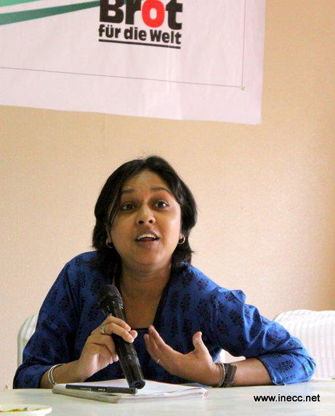
Equity in Climate Change GHG reduction in Aviation-Nupur Chowdhary, Jindal Global Law College

Moderator: Srnivas Krishnaswamy, Vasudha Foundation, New Delhi
The main argument put forth by Nupur Chowdhary’s presentation was that ICAO should not be the primary forum for negotiation as it only looks at ‘capacity aspects’ and not ‘historical responsibility’. The mandate of the ICAO is therefore limited. It does not have a framework to take into account CBDR. It is a body to provide technical expertise. EUETS should be challenged as a unilateral measure and the strategy of EU to pressurize ICAO. There has to be a focus on negotiation but also on equal emphasis on adaptation and financial mechanisms. The UNFCCC is the best forum to negotiate the equity argument.
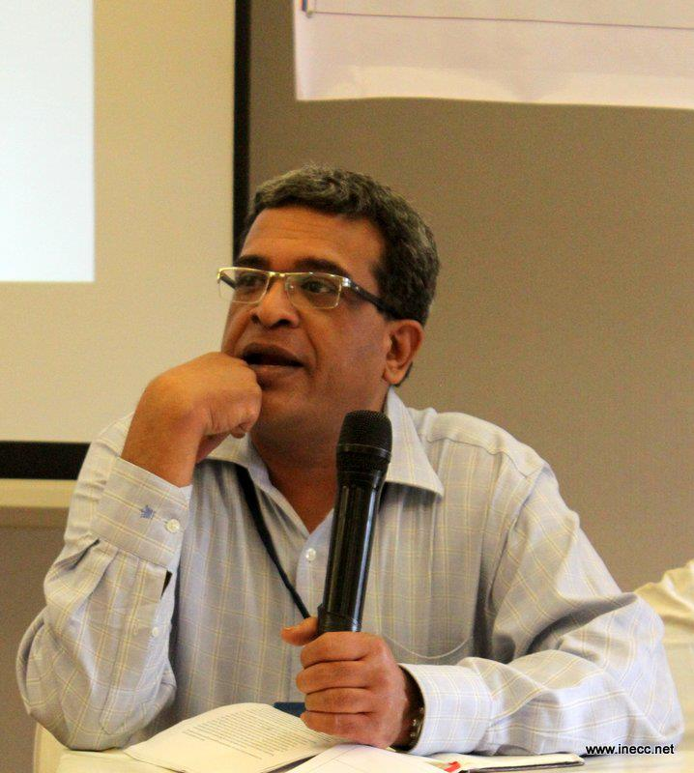
Presentation looked at Resolution 36(22) and 37(90). She focused on the legal basis of ICAO. . Article 37 (90) supersedes Article 36(22). Recitals in the preamble though important for interpretive role and indirect legal effect do not have any legal value. The Article 2.2 of Kyoto Protocol states that “The Parties included in Annex I shall pursue limitation or reduction of emissions of greenhouse gases not controlled by the Montreal Protocol from aviation and marine bunker fuels, working through the International Civil Aviation Organization and the International Maritime Organization, respectively”.
ICAO goals on climate change revolves around Global goals of improving annual fuel efficiency by 2% and Stabilizing global CO2 emissions at 2020 levels. Since, ICAO is limited to providing technical expertise and therefore all sectoral negotiations should shift to UNFCCC and the EUETS should be challenged as a unilateral measure under WTO/ICAO.
Reflections/Comments
- It is not only a question of historical responsibility when until after World War II the industry was fairly small and as such it cannot be divided and the question is of future and collective responsibility. Going by the polluter pays principle -the airlines and the passengers are not paying for it. Fuel tax has become a dirty word. In India the airlines are passing on all responsibilities to the passengers but the pollution tax. In Europe there is VAT for everything but why do fuels have no taxes? Why should the air traveler not pay taxes? Nondiscrimination is between countries it is not successful in aviation and shipping. The focus on MBMs is because ICAO has ruled out every other option. And Europe is being hampered from doing anything.
- No country can put pressure on other countries to take up its legislation; there should be consultations. EU decided to respond to aviation emissions by an enactment. The revenue generated from the same went to the general funds of the country and not for climate action. Issues like these needs to be looked at.
- Negotiations take time and all hope is on ICAO that it should be able to do as it is important for UNFCCC.

Day II

10th May 2013.
Beginning of the session with a recap of the previous day- Siddharth D‘Souza

Perspectives from Airline representatives:

Manish Goswami, Jet airways

Moderater: Pradeep Esteves
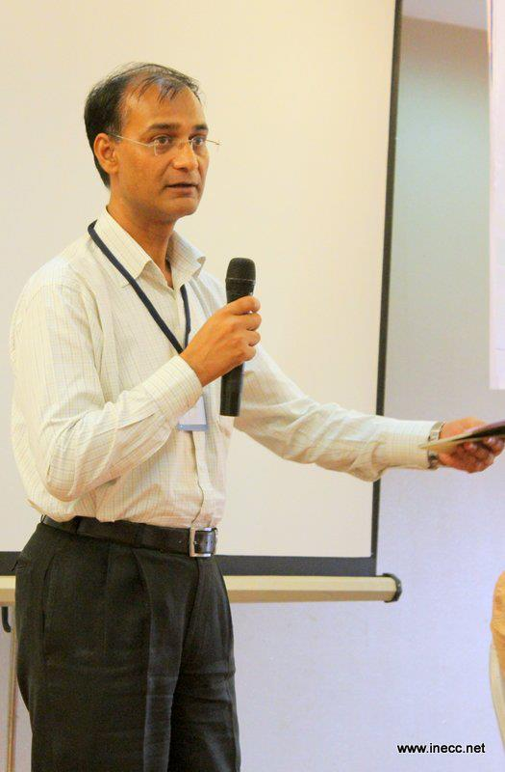
Manish Goswami posited the Jet Airways perspective. His talk touched upon three fundamental issues of aviation -emissions projections; the projected gaps and containment measures and implications. He stated that although specific parts and guidelines of the EUETS had been highly beneficial to them for improving their efficiency they were against the idea of MBMs. The Gap assessment 2011 UNDP report in its chapter on international aviation by David Lee points out that it is technologically possible to reach the desired level of reduction in emissions. Aviation and Shipping are both classified as global emissions and there is no agreement for framework of the regulation although discussions have been emerging. Baseline emissions-2005 projections show that civil aviation emissions are expected to grow. The projections for 2020 show that there is need to decrease emissions from other sectors as well. In aviation operational measures like improvement in air traffic management, adopting continuous descent and increasing the capability of air traffic could be some of the ways of reducing emissions. But these are often limited by infrastructure. There is a trade-off between the reduction of CO2 and NOX and between noise and efficiency. There have been developments coming through the use of the current technologies although biofuels are not presently economically viable or environmentally sustainable.
The airlines do not want MBMs in aviation as they are economically not viable and MBMs on mutual consents or regional frameworks and agreements would led to distortion of the market which is unfavourable the industry. They stated that they were doing their best for their economic sustainability. In case of MBMs becoming mandatory, the airlines would favour a global framework wherein the entire route of the departing international flights should be considered for accounting emissions. The mechanism for transfer of funds should be transparent and funds generated be of a global nature in the line of GCF (Global Climate Fund).

Comments/Questions
- Use of biofuels is not feasible presently whether it is in terms of economic efficiency or in terms of sustainability especially related to land use and food security . It is to be noted that biofuel also lead to combustion and technically the product of emission is the same, it is only the source that is different. It is just that over the lifecycle there is less emission. In UK there are certification courses for this and there are ongoing research on sustainable biofuels. So there has been some work done in that area.
- At the moment there are concerns that biofuels would lead to competition with food production and the aviation sector is looking at algae. We also have to take note of what kind of land is being used-whether it is prime agricultural land or wasteland. Countries should have policies on these.
- Sabine: In Germany discussions with Luftansa will be not so open. The aircrafts are very old and they say that life cycle of 25 years is required until a fleet is exchanged. Is it we have to wait another 20 years till you could make certain technical improvements?
Response: If you already have a fairly young fleet of aircraft then it takes time. At the manufacturers side the things are improving and as and when the requirement arises they will be phased out.
- Sabine: The Indian government seems to be more intent in protecting the interest ofa small elite. There seems to be a substantial fear that it will not be relegated to aviation alone and therefore it’s important to have safeguards.
Counter response: How will the safeguards be ensured?

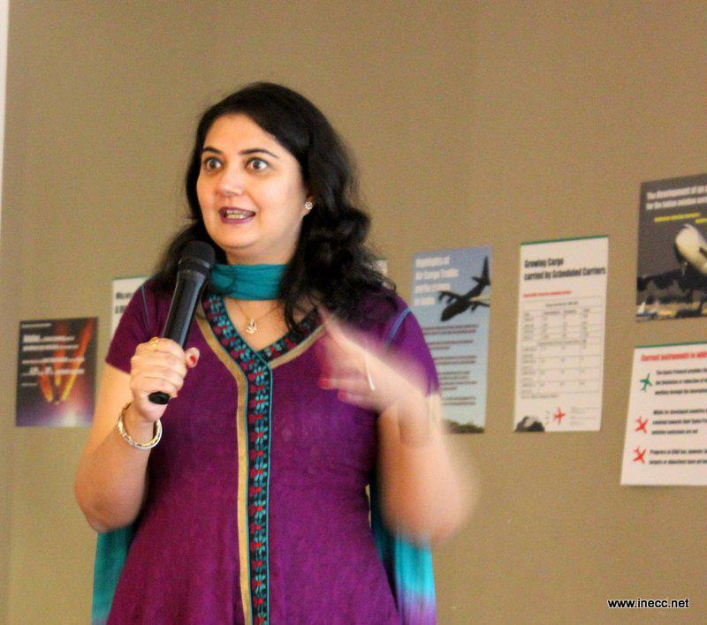
Harpreet A. De. Singh, Air India
Harpreet Singh stated that as the national carrier the perspectives of Air India were slightly different although the concerns with regards to efficiency and fuel management largely coincided with that of the private carriers. The national carrier had a lot of social obligations in addition to the need to remain viable. There were GoI (Govt. of India) delegates who were to be given the service and some parts of the country like the North-East, Kashmir and Andamans had to be connected by them.
The issue of climate change she said, was one that had impacts on the planet overall and not just the country, so it had to be taken up with outmost seriousness. New technologies have taken us to a new area where we have controlled emissions to a large extent. All carriers in India are much younger and at the global standard and they have been incorporated with specific design elements. The tools given by the EUETS has been very effective and we are continuing with the monitoring system.
The opinion from Air India was that a global scheme for aviation emissions reduction should be voluntary and should be seen primarily from a revenue generation perspective. The RTK is not only about efficiency but is linked to revenue from greater number of passengers and it is a part of their business goal but Air India cannot lose sight of our socio-economic benefits. It should not be seen as a competition. There have to be sensitizing programme and there has to be motivation. Addressing climate changes is not simply a question of management but also of genuine human involvement and in this respect Air India had undertaken and institutionalised an array of voluntary activities that ranged for improving work ethics to forestration.
Avik Bhattarcharya, , Boeing Commercial Airplanes
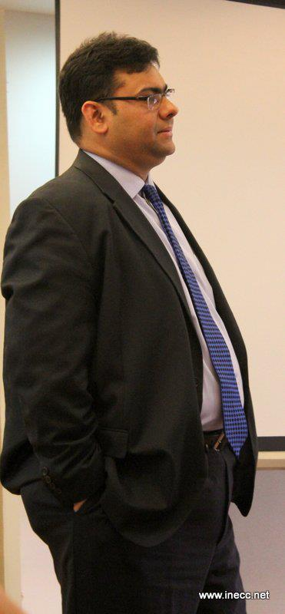
Avik Bhattacharya presented the Manufacturing Industry Perspective. He said that a lot of thrust to make aviation sustainable in the light of ensuring environmental sustainability. Presenting the figures of the highest growth in aviation, he said that the areas that Boeing was focusing on are: Lighter planes with smart fitment. Touching on the technical aspects, he said that efficiency is driven by the engine parameters, fuel burn and the fan diameter which plays a crucial role in deciding how big the planes can be. He then gave an overview of the aircraft 737 which was designed to reduce drag and reduce fuel burn and noise reduction. There is a lot of room for improvement, and Boeing is looking at portfolio of measures-growth capacity, cost of congestion and delay.
In terms of transfer of technology to India-787 is the latest and Air India has six 787 Aircrafts. This plane is made out of composites against aluminum structures (used earlier) so there is a saving on weight. It has a 30% smaller noise percent. So from the side of the producers the aim was to make engines more efficient, efficient management of air traffic and modification of routes to the shortest distance.

Questions/Comments
- Is there any data available on emissions from the production of planes?
Response: The emission trajectories in aviation are based on the fleet projections and not extrapolated.
- It could be argued that the changes the airlines are making are for their own good and there is not much being done at the level of environment? When you fly the president of India and it is cost to operate, these environmental costs are part of your cost and we should be paying and they should be contributed. If you really say then the environment is integrated in life and it should be included in the cost of the aircraft.
- How is the increase in carbon footprints brought about by improving operations and reducing congestion in airports through expansions accounted for?
Response: It is the fundamental duty of the aircraft to land you in time and so for that these measures have tobe taken. Right now at the airport total emission from airport there is 5% there and rest 95% is airline related.
- What percent of it is actually recovered or recycled?
Response: That depends on the model of the airplane. Those built of aluminium can be recycled 15% and these include copper wiring. This number will look better as we move forward. The grade of aluminum being used currently is high which can be recycled for a specific use.
- There is a resistance from airlines on fuel tax, how will a global tax impact you and won’t people get used to paying a certain amount of tax?
Response: Taxes are different from MBMs which are not applicable on all emissions which are beyond cap limits. So in a way if you have been able to reduce fuel burn and you have an incentive it is a different system altogether. Why we are opposing and whether it is tax or not is because we are very sensitive to the price-as it is the airlines have not been doing very well.
- Several of us are involved with activities like low carbon agriculture and I keep wondering whether the food given to the passengers figure in the discussions?
Response (Air India): On the catering side we have generally three to four main caterers. We have made efforts to reach out to cooperatives and we have been negotiating with the main caterers to outsource some of their work and ensure the ISO rating so that these cooperatives get a boost.
- It has been observed that getting a train ticket is extremely difficult. And in this context how would a tax on air tickets put a risk on airlines? Targets and voluntary measures have been there for a long time and not much has come out of it?
Response: Boeing-The fact is whenever there is substantial price increase for the past 5 years there is a drop in traffic..
Air India- Any airline concern is to look at a business model for economic sustainability and profit. Putting fuel tax implies increasing the airfare which finally has to be borne by the passengers. If the passenger is paying I don’t have anything to say to that. But the global monitoring system should be voluntary.
Comment: For instance in Gujarat eg-there is an extra 5% surcharge on hotels and restaurant and there was one day strike and then everyday starts paying.
- What kinds of social responsibility are the airlines taking?
Response: AI- we have connectivity so we connect areas that are not indulged by private airlines. As far as CSR activities go we have adopted an island in Nicobar. Even though we are running at a loss we continue to run schools. We are involved with‚ Angels of Air India‘.
- There has to be an alternative to flying. For long hauls flying is understood but for short hauls we need an alternative to flying..
Response: Boeing-I agree with the spirit of what you are saying but I cannot agree with proposal. If we look at the population, Delhi has a population of 18 millions and Kolkata 15 millions. Those are the volumes that we are talking about. Airlines in India are a supplement and not an alternative. And there are other issues related to land procurement , laying more ground ,infrastructure constraints too with railways
- Aviation is by far the most expensive form of travelling and at the moment pollution is not being taxed. India passes the tax to the consumers for everything but pollution. We have to make sure that international aviation pays for the dirt it creates. It is the airlines responsibility not to resist it.
Response: Airlines industry is aware of the issues, but have their own constraints and it will go on to try to make the changes.
Winding it up!
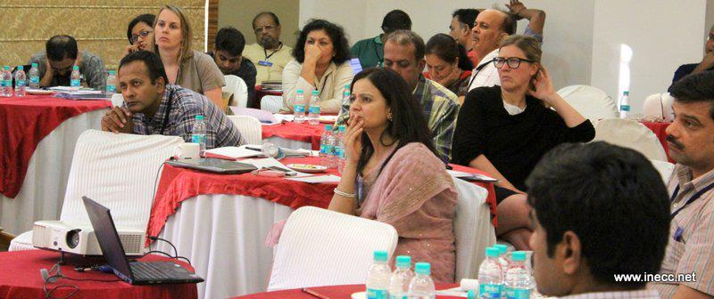
Concerns raised and Learnings from the workshop
It was felt by the organisers and the participants unanimously that it was a dialogue that had to be taken forward and that this workshop was merely a beginning for larger discussions and advocacy initiatives. For this need was felt for strengthening and broadening networks and communications. The dialogue needed to be taken forth and a position articulated wherein it would be communicated to all stakeholders including the unions to put pressure on the government to take necessary steps. For this the Air travellers association are critical and they have to be reached. Further advocacy needed to be taken up to spread awareness about the harmful environmental impacts of tourism. There should be emphasis on community based and responsible tourism wherein the local people have the power to make decisions. Lobby and advocacy was needed both outside and in UNFCCC. So far the Government of India appeared to be speaking only to the airlines in formulating its positions and there was a need to take into account the views of the CSO. The GOI also needed to do more than merely take into consideration the interest of the elites. The civil society organisations needed to actively take part in taking these concerns forward.
The group was apprised of aviation related data which could be accessed from the DGCA public domain which can be accessed at www. Dgca.nic.in. They have also opened an environmental cell and some initiatives to work towards environmental goals and also come with environmental advisory circulars.
It was felt the aviation emissions needed to be seen holistically in the larger transport sector. It was not only about aviation emissions but also the massive expansion of airport infrastructure and related issues of displacement that had to be taken into account. There was a need to study and monitor more closely the recycling systems of airlines and the waste produced in aviation as well as pollution impacts at the point of production. Aviation fuel and the responsibility of airlines that procure fuel from these refiners and impacts on people living in the vicinity of such refineries. Further, the production and use of electricity had to be considered with ensuing pollution. There was a need to look at the ecology and environment and biodiversity aspects too. A need was felt for undertaking sectoral research on railways, roads and other forms of transport. Military aviation was another sector where not much was known.
The airline representatives were appreciated for being a part of the discussion. The problem was not to do with profit making agenda of the airliners but it is done in a highly irresponsible and unsustainable manner. It was felt that the airlines had undertaken the operational and technical measures towards ensuring efficiency as a part of their cost effectiveness and not for directly for the cause of the environment. Therefore more needed to be done. On the EUETS the airlines representatives expressed that the EUETS had been useful in increasing efficiency by providing valuable tools for monitoring and corrections and they would be in favour of a global framework. However the EUETS was not acceptable as it was a unilateral measure. The GOI stated its position that MBMs would not be endorsed as it does not address equity and its viability needs to be established. Concerns were expressed that it would set precedents and not be relegated to aviation alone. There needed to be safeguards against these. The group acknowledged that this has to be taken up for policy advocacy. In terms of the regulations there was a need to safeguard CBDR and take into account the historical responsibilities. On the issue of whether the regulations should be mandatory or voluntary more were in favour of voluntary as a starting point but clocked with a model where the trajectory would be measured and monitored.
There was a need to think of ways in which these discussions would benefit communities at the grassroots. In relation to the use of central resource, the group felt the need to monitor how the money from the fund would be used to support / benefit the grassroots communities .It is most important to look into what happens to the tax/ levies once it is collected. As a starter, it was suggested that a model (adaptive – compensatory) could be initiated at the grass roots.

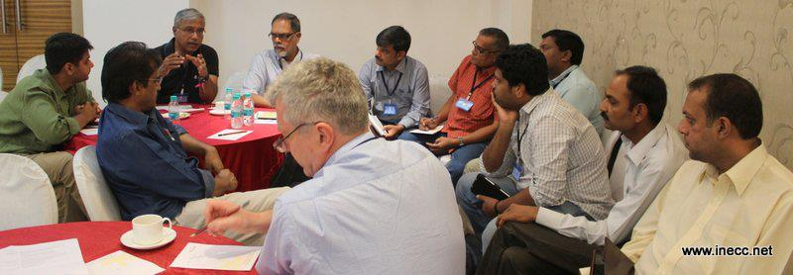
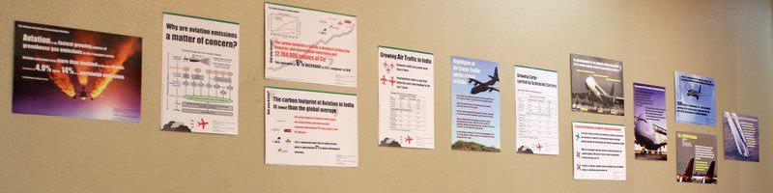

International Civil Aviation Organization (a UN specialised Agency) serves as the global forum for its 191 Member States seeking to foster and support the sustainable growth of air transport.
Brief of article 2.2- In 1997, the Kyoto Protocol (Article 2.2) gave responsibility for aviation emissions to developed (‘Annex I’) countries working through the Civil Aviation Organizations (ICAO)
Lee et al; 2009

